

Copper Wrist Brace

Item No: A01

Material: Copper fiber

Size:one size fits all

Color: Yellow

Packing: 1 piece / opp bag,100 pcs/carton

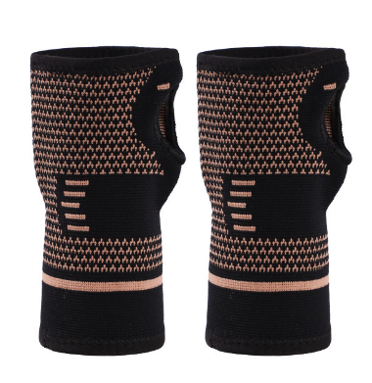

Compression wrist braces are made of high content of copper infused fiber and high elastic nylon, which is high flexibility, breathable, lightweight, soft, moisture wicking and skin-friendly, copper fiber keep your hands dry and fresh all day, more comfortable to wear. Wrist protector not only help you get the support and relief you need, but also protect your hands in daily activities

**Common Examples of Use**

Weightlifting,Fitness,Cycling

**Product Features**

Elastic weaving, pressure protection, one-piece weaving to prevent wrist injuries during exercise.

Surround fit, copper protection, added copper nylon weaving, further protection.

Breathable fabric, comfortable and not stuffy, soft and comfortable, light and breathable, bringing a comfortable sports experience.