

Aluminum bar support wrist brace

Item No: A09

Material: sandwich mesh fabric

Size:one size fits all

Color: Black,Gray

Packing: 1 piece / opp bag,100 pcs/carton

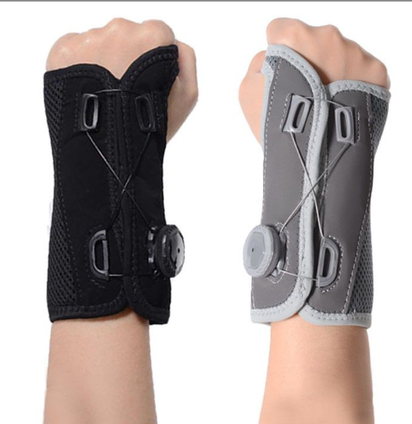

The palm uses a high-strength, light-weight arc-shaped aluminum alloy support plate, and the two soft board support strips on the back of the hand perfectly fit the wrist curve to strengthen wrist protection and fixation. After pressing the button, gently twist the rotating chuck to stretch the tempered lace line in both directions, gradually adjust the pressure, evenly force, and fit the wrist.

**Common Examples of Use**

Wrist fracture and sprain

Carpal tunnel syndrome

Fracture rehabilitation use

**Product Features**

Comfortable to wear, the knob wrist guard adopts an adjustable knob design and aluminum sheet support to create a custom fit for most palm shapes.

Wrist protection, support and fixation. Failure to pay attention to wrist protection can easily cause a variety of wrist pain conditions.It is stable while the thumb can move freely.