

Strengthen Wrist support

Item No: A06

Material: Nylon

Size:one size fits all

Color: Black,Skin,Gray

Packing: 1 piece / PE zipper bag,400 pcs/carton

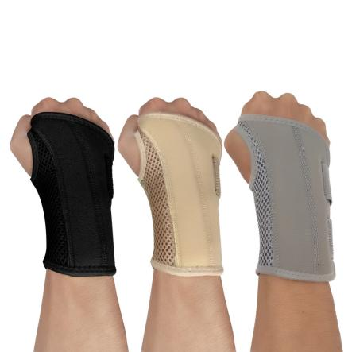

The product composition is 40% nylon, 45% polyester, and 15% neoprene. It has upper and lower supports and provides effective protection. The palm has hard plastic support and the back of the hand has soft plastic support. It is easy to wear and comfortable to wear without pinching the hand.

**Common Examples of Use**

Basketball,Badminton,Volleyball

**Product Features**

Exquisite workmanship, neat wiring, firm and beautiful.

Built-in net pocket, good wrapping, more stable to wear.

Elastic pressure, full elasticity, firm and durable.

High-viscosity Velcro, durable, firm and reliable.